Instructions for administering the tablet at home

Please follow these instructions when administering the tablet to your child.

- Administered the tablet once daily at approximately the same time each day.
- Take the tablet from the blister package after carefully removing the foil with dry hands.
- Place the tablet immediately under the tongue where it will dissolve within 10 seconds.
- Do not administer study medication with food or beverage. Food and beverage should not be given for the following 5 minutes.
- Wash hands after administering the tablet.
- Child should be observed for at least 5 minutes.
- If your child shows signs of distress or discomfort after the tablet, or if you feel that your child is not tolerating the tablet, then please get in touch with the local research team at the telephone number; xxxxx
- If patient’s parent/guardian forgets to administer study medication, do not administer two tablets the following day. Take the next tablet at the normal scheduled time the next day.
- If patient’s parent/guardian misses more than 7 days of study medication, the study site must be contacted before restarting.
- Please keep all the empty packaging. And return it to the local research team when you attend the Centre for further supply of the tablets and/or when you attend the Centre at your annual visit.

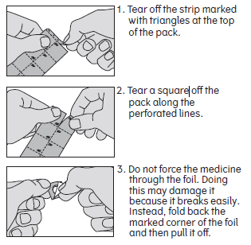
Storage instructions and warnings for study treatment

Keep out of the sight and reach of children.

The tablets should be kept at room temperature.

Do not use the tablets after the expiry date which is
stated on the blister and carton after EXP.
The expiry date refers to the last day of that month.

Instructions for administering the tablet

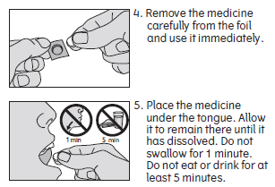
Always take the tablet exactly as the study team has told
you.

The dose is one tablet daily.

Make sure your hands are dry before handling the tablet.

Administer the tablet as illustrated in the pictures on the right:

