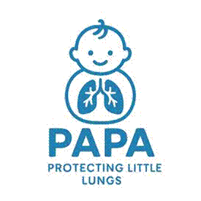
PAPA Stage 2 Parent/Carer Information Sheet
Trial title: Preventing childhood Asthma using Prophylactic house dust mite Allergen immunotherapy
You are being invited to consider including your child in the PAPA trial. All backgrounds and abilities are welcome to take part!
For more information please see our website: https://papastudy.uk
Before you decide it is important for you to understand why the research is being done and what it will involve for your child. Please take time to read the following information carefully and discuss it with others if you wish.
Part 1 – Why is this trial being done? (pages 2-14): This section tells you about the purpose of this trial and what will happen if your child takes part.
Part 2 – Frequently Asked Questions (pages 15-18): This section gives you more detailed information about the conduct of the trial.
Part 3 – Participant Privacy Notice (pages 19, 20 & 21): This section explains how we will look after all the information collected about your child and use this information properly.
Part 4 – Contact details (page 22): This page includes contact details for the research team and out of hours emergency contacts details.
Part 5 – Glossary (page 23, 24 &25): This section explains some of the terms and words used in this document.
Please take your time to read this information sheet. If anything is not clear and/or you require more information before you decide whether or not to take part in the study, please contact a member of the study team (details at end of information sheet). Thank you for taking the time to consider your child taking part in our trial. If you are happy for your child to participate you will be asked to sign a consent form.

PART 1 - Why is this trial being done?
What is the purpose of the trial?
Asthma is a disease which causes wheezing, coughing and/or tightening of the air passages which can be relieved with medication. Asthma is one of the most common long-term illnesses in children and there is no cure, but it may be possible to prevent asthma. Most children in the UK with asthma are allergic to house dust mite (HDM), and this allergy contributes to asthma symptoms.
We already know that if babies are given peanut butter or egg to eat when they are young, they are less likely to develop allergy to peanut or egg. In this trial, we want to test whether using a similar approach with HDM might stop babies developing allergy to HDM and asthma.
We have completed a small trial with 111 infants less than 1 years old which gave an indication that this treatment might prevent asthma. Also, importantly, the new treatment did not cause any side effects in this small group. Our PAPA trial aims to provide clear proof whether asthma can be prevented through a simple daily tablet of HDM started in the first year of life, before HDM allergy has developed. This research study involves several NHS hospitals and a range of families whose babies are thought to be at risk of developing asthma.
Why have I been chosen?
Your child is being asked to participate in this trial as your child is up to 12 months and deemed at high risk of developing persistent (lasting) asthma. A total of 434 children are being enrolled in this trial at 12 NHS hospitals across the UK.
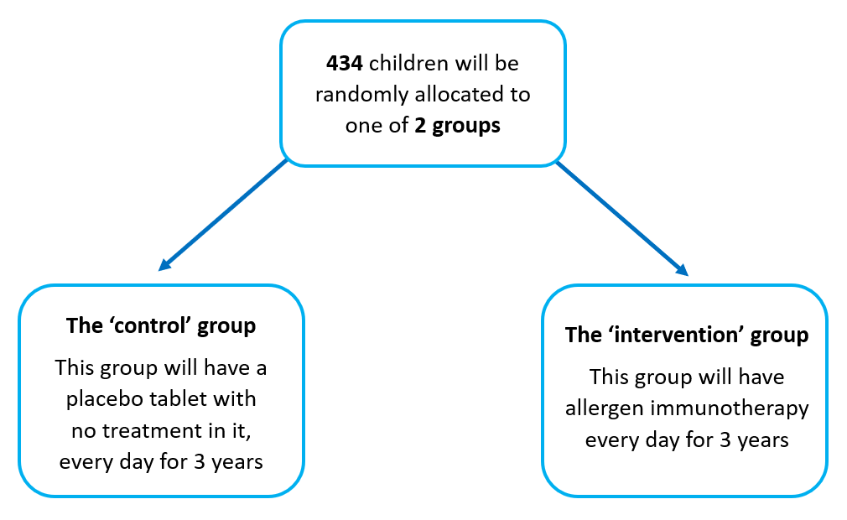
This study is a randomised, double blind, trial. This means neither you nor your doctors will know what your child is getting. The decision about using the HDM tablet treatment is made randomly, like flipping a coin. There is an equal chance of getting the trial treatment or what we call a placebo. A placebo is a dummy pill which looks like the real thing but is not. It contains no active ingredients. All children will get the same number of visits and assessments done at each visit.
Do I have to take part?
It is up to you to decide whether or not to take part. If you do decide to take part, you will be given this information sheet to keep and be asked to sign a consent form. If you decide to take part, you are still free to withdraw at any time and without giving a reason. A decision to withdraw at any time, or a decision not to take part, will not affect the standard of care your child receives. If you would like to withdraw after agreeing to take part, please speak to your doctor or care team.

What will happen to me if I take part?
Your child will be in this research trial for about 3 years. Your child will take the trial medication, Acarizax®, or placebo for the full 3 years. There are no additional visits after this time.
Before any trial procedures are done the trial doctor and research staff will explain the trial to you and ask you to read this information sheet and the consent form. The trial personnel will answer any questions you may have and what is being asked of you or your child. If you decide for your child to participate you will be asked to sign a consent form and a copy will be given to you.
The trial is conducted in 2 parts:
(1) screening and baseline visits
(2) daily dose of Acarizax® or placebofor 3 years.
Below is a schedule of the visits and appointments your child will need to attend with each visit explained in more detail.
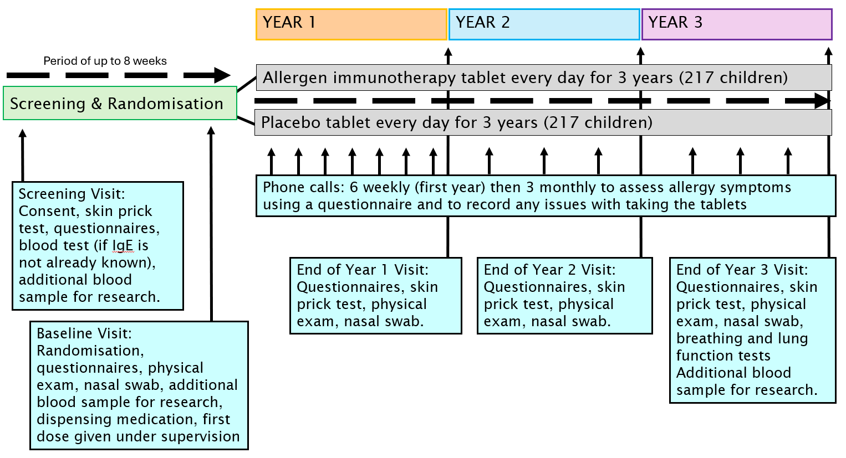

IgE = Immunoglobulin E (IgE) is a type of antibody, a protein produced by the immune system to fight off foreign substances. These are produced during an allergic reaction.
Screening Visit (completed at your local hospital, will last around 1 hour)
If you decide to join the research trial, some screening tests will be done first to see if your child is eligible to participate. We will review your child’s medical history of asthma and allergies. If your child has not been seen in the clinic, we may ask for permission to contact your child’s doctor to get a copy of any medical records about to their allergies.
At the visit we will do the following:
- Skin Prick Test: Skin testing will be done to see if your child is allergic to 9 different things. They are:
  - grass pollen mix
  - tree pollen mix
  - dog
  - cat
  - house dust mite (2 kinds)
  - cow’s milk
  - egg
  - peanut
This test is done on both of your child’s arms. This test is done by pressing a drop of concentrated allergen (such house dust mite, dog) onto their skin with a device that scratches the skin slightly. This test will take about 20 minutes.
- Blood Draw: We will draw blood from your child’s arm. We will take up to 1 tablespoon (max.15 ml) of blood from a vein. The tubes of blood will be sent to a laboratory to measure IgE. Immunoglobulin E (IgE) is a type of antibody, a protein produced by the immune system to fight off foreign substances. These are produced during an allergic reaction. The allergens we look for are the same ones from the allergy skin testing. A numbing cream may be put on the skin, before the blood draw, to reduce the pain of the needle stick.
Any blood that is left over from the routine test for IgE will be stored for research carried out in the PAPA trial, together with samples collected later in this study. The research will look into which parts of the immune system are involved in asthma and if there are other ways we can prevent asthma in the future.
Baseline Visit (completed at your local hospital, will last around 2 hours)
The screening and baseline visits can be combined where IgE blood tests are not required (the result is already known and in your child’s medical notes) to confirm if your child can take part. Once your child has been confirmed as eligible, you will be invited to attend a baseline visit.
Your child will be “randomised” into one of two groups. One group will receive the treatment (Acarizax®) and one group will receive placebo. Randomisation means that you are put into a group by chance. It is like flipping a coin. Your child will have a 50/50 chance of being placed in the trial treatment group or the placebo group. You cannot choose what group your child will be in. Since the expectations of participants or their parent/ carer and doctors can influence the results of a trial, neither you nor the research investigator will know which group your child is in until the trial is over. But, if there is an emergency such as admission to A&E, the research investigator can immediately find out which group your child is in , if this information is required to ensure the safety of your child
After your child is randomised, at the visit we will do the following:
- Questionnaires: We will ask detailed questions on your child’s history of allergies and asthma using the Family Demographics and Medical History questionnaire. We will also ask you to complete another questionnaire called the Allergy and Environment questionnaire for information on your child’s diet and environment You can complete the questionnaires on your phone, tablet or computer or a paper form. These should take around 1 hour to complete.
- Measurements: Measurements of your child’s height and weight will be taken. We will also collect your child’s heart rate and blood pressure.
- Physical Examination: Your child will be examined for any wheezing or itchy skin. If your child has experienced any atopic dermatitis (itchy skin) an assessment will be completed to record the how frequent and severe this is.
- Review of symptoms and medications: The research team will ask you if your child has experienced any symptoms since being put in either group and confirm any current medications they are taking. The team will also review your child’s medical records for anything that may impact the trial such as new illnesses.
- Blood Draw: We will draw blood from your child for use in research to better understand how this treatment might work in preventing asthma and further to investigate into other ways asthma can be prevented.
- Mandatory: We will take up 1 tablespoon (max.15 ml) of blood from a vein for use in research as part of this trial. As your child is young we may only be able to collect a smaller amount. This sample will be used to assess what type of allergic and protective antibodies are present in your child.
Optional: At some hospitals, we are also collecting a further up to 10ml of blood for additional research. If this hospital is taking part, your research team will let you know. This is optional and if you do not agree for your child to take part this will not affect your child taking part in the rest of the trial. This additional sample will be used to see how immune cells react to house dust mite allergen.
- Nasal swab: We will clean your child’s nose with a swab and collect the sample in a sample kit which is a bag that collects any secretions from the nose. These samples will be used to understand of how your child responds to the intervention.
- First Dose: The first dose (Acarizax® HDM/placebo tablets) will be given at the baseline visit followed by an observation period of 60 minutes. This is to ensure your child does not have any unexpected reactions to the trial medication and is in the presence of medically trained staff if anything was to happen.
The 60 minutes observation period will include the following:
- Measurements: Before and after the dose your child’s heart rate and blood pressure will be checked. The doctor will also listen to your child’s chest and their breathing will be checked using a stethoscope. The doctor will review all these tests and your child will be discharged home only if these assessments show satisfactory outcomes. If there are any concerns your child will remain under observation.

- Observations after the baseline visit: Research nurses will call or text parents/caregivers the following day, a week and 2 weeks after the first dose to ensure no side effects has occurred. If there is any concern, your child will be seen for an assessment at the clinic.

Treatment Phase with trial medication (3 years)
Your child will continue to take trial medication, Acarizax® or placebo, every day for 3 years. There will be a mixture of phone calls and clinic visits during this time to see how your child is doing.
We will help check the medication is being taken each day by you recording daily in an application called MedSearch, which is available on your smart phone or tablet. Your research team will show you how to use the application when you attend a visit. The recording will take no more than 2 minutes each day. The application will send reminders for you to complete this information. Your child’s data only be identified in the application by a unique ID number, we will not be able to see your name or phone number. You are also able to record if you have any concerns and a member of the research team will get in contact with you.
If you do not have a smart phone or tablet to use for this, please let your research team know. You are still able to take part in the PAPA trial.
If you have any technical difficulties with the MedSearch App you will be provided with a paper diary to record daily doses in the meantime.
Phone contact
Parents/caregivers will be contacted over the phone every 6 weeks in the first year and every 3 monthly in years 2 and 3. The phone calls will take around 30 minutes.
At these times we will ask you:
- Questionnaires: We will ask you to complete the Allergy and Environment questionnaire online (on your phone, tablet or computer) as completed previously.
- Review of Symptoms and Medications: We will check your child is taking the trial medication by reviewing the MedSearch App data and record any new symptoms experienced or other new medication being taken.
Annual in-person visits (completed at your local hospital, will last around 1.5 hours)
In addition to the phone calls from the research nurses, you will be asked to attend clinic once a year (3 in total). You may also need to attend the hospital approximately once between each annual visit to pick up more trial medication. Your research team will advise if this is required before you leave each visit.
At the visit we will do the following:
- Questionnaires: We will ask you to complete the Allergy and Environment questionnaire online (on your phone, tablet or computer) or on paper as completed previously. This will take about 20 minutes.
- Review of Symptoms and Medications: We will check your child is taking the trial medication as they should be via the MedSearch App and record any new symptoms experienced or other new medication being taken.
- Measurements: Measurements of your child’s height and weight will be taken. We will also collect your child’s heart rate and blood pressure.
- Physical Examination: Your child will be examined for any wheezing or itchy skin. If your child has experienced any eczema an assessment will be completed to record how frequent and severe this is.
- Allergy Skin Testing: The same allergy skin testing that was completed during the screening process will be completed again. This test will take about 20 minutes.
- Nasal Swab: We will clean your child’s nose with a swab and collect the sample in a sample kit which is a bag that collects any secretions from the nose. These samples will be used for understanding of how your child responds to the intervention
- Blood Draw: At the final visit (year 3, aged 3½ to 4 years) only, we will draw blood from your child for use in research to understand better why some children develop asthma and ways to help prevent it.
Mandatory: We will take about 1 tablespoon (max.15 ml) of blood from a vein for use in research as part of this trial. This sample will be used to assess how treatment has influenced the allergic and protective antibodies present in your child.
Optional: At some hospitals, we are also collecting a further up to 10ml of blood for additional research. If this hospital is taking part, your research team will let you know. This is optional and if you do not agree for your child to take part this will not affect your child taking part in the rest of the trial. This additional sample will be used to see how immune cells react to house dust mite allergen.
- Lung Function Test: For participating sites with the equipment, at the final visit (year 3, aged 3½ to 4 years) only, your child will be asked to perform a lung function test (Impulse oscillometry). Impulse oscillometry is a test that uses sound waves to measure how much resistance there is to the normal movement of air in and out of your lungs when you are breathing at rest. This test involves breathing normally through a tube attached to a small speaker. We will ask your child to sit and put a peg on your child’s nose. A physiologist may hold your child’s cheeks from behind to ensure a good seal on the tube with their lips. While breathing normally for 30 seconds, sound waves created by the small speaker attached to the mouthpiece will be sent into your child’s lungs. Your child may feel a slight pressure when your child breathes. We may ask your child to do this several times. This test will take about 20 minutes.
- Peak Flow Test: We will also ask children to perform peak flow readings during the last visit (year 3, aged 3½ to 4 years) only. A peak flow test involves blowing as hard as you can into a small handheld device called a peak flow meter. By measuring how fast you're able to breathe out, your peak flow score can indicate whether your airways are narrowed in conditions like asthma. This test will take about 5 minutes.
- Exhaled Nitric Oxide Measurement: A fractional exhaled nitric oxide (FeNO) level test will be completed at the final visit (year 3, aged 3½ to 4 years) only. This test involves slowly blowing into a machine that measures nitric oxide levels and will only take a few minutes. This test can help diagnose and manage asthma. It measures the amount of nitric oxide that is exhaled from a breath. Increased levels of nitric oxide are associated with swelling of lung airways.
After you have consented, parents/caregivers will have access to a 24 hour telephone number manned by research nurses, doctors and consultants who will give appropriate advice. Advice will be given with regards to appropriate action to take.
If there is any indication that your child may have developed sensitisation e.g. if they had a reproducible rash or swelling following administration of the tablet, they will be seen at the hospital and skin prick tested.
Will I get paid for my child participating?
You will not receive any payment for your child taking part in the research but we will offer you a gift for your time of £15 per visit to the hospital (up to 5 visits, £75 maximum). You are also able to claim back expenses for your travel for the study visits up to a maximum of £250. You will receive the gifts and expenses after attending the required visit.
You will be required to share receipts or travel distance with your hospital to claim expenses. It may also be necessary to share your bank details with your hospital in order to process payments. Your research nurse will explain this to you.
What do I have to do?
You will be provided with detailed instructions on how to take the tablets, what to look out for after doses, and what to do if you have any concerns. You will be given training and practical demonstration by research nurses on how to administer the tablet. You will also be provided with clear written instructions, which will explain how these tablets should be used once daily at home.
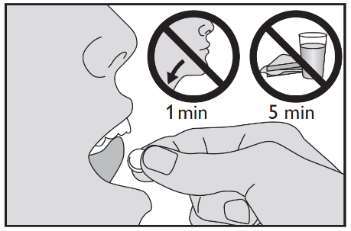
The HDM/placebo tablet should be taken with dry fingers from the blister unit immediately after opening the blister and placed under the tongue by the parent/caregiver, where it will dissolve. If possible, swallowing should be avoided for approximately 1 minute to minimise side effects. Food and drink should not be taken for 5 minutes after intake of the tablet. The daily dose should preferably be taken in the morning to observe for any side effects.
What is the treatment or intervention that is being tested?
The treatment to be tested in the trial is HDM tablet with placebo as a control. The placebo tablets are identical to the active tablet with respect to appearance, smell and taste but contain no active ingredients. The dose is 12 SQ-HDM and is given in the form of a dispersible tablet placed under the tongue. The tablets contain gelatine (from fish source). If you have any concerns regarding this, please speak with your research team.
There are no known interactions between the HDM tablet and other well known foods or medication. Your child will not have to stop taking any medications or change their lifestyle while taking part in this trial.
You will be given be given a card (similar to a credit card) with details of the trial your child is taking part in. You should carry it at all times as it will provide important information to anyone else treating your child. You could take a photo on your phone to help with this.
What are the alternatives for diagnosis or treatment?
If you choose not to take part in this trial, you will receive the standard treatment if your child went on to develop asthma. There are currently no methods to prevent asthma. If you decide for your child not to participate, your other choices may include:
- Getting no treatment to prevent your child developing asthma
- Getting standard treatment for your child if they do go on to develop asthma without being in a trial. The alternative to participating in the trial, is to treat asthma symptoms if they develop, according to your child’s doctor. Currently there is no medication available to prevent asthma symptoms from getting worse as your child grows older.
Your child does not have to take part in this trial, it is completely voluntary. You have the right to decline your child’s participation in the trial for any reason and this will not affect the quality of your child’s care or treatment.
What are the side effects of any treatment received when taking part?
Allergies are an overreaction of your immune system in response to a substance that is normally harmless.
HDM is safe for both children and adults, with only a few mild side effects, when used to treat allergies like asthma and rhinitis caused by HDM in people who have encountered HDM before (“are sensitised”). Sensitisation is the first step in developing an allergy. Allergic reactions don’t happen the first time you encounter an allergen. To begin with, your immune system has to recognise the allergen, this process is called sensitisation. We plan to give HDM allergen to infants who are not known to be sensitised and hence the risk of adverse effects is very low.
The safety of the HDM tablet has been tested in 21 completed trials with people of all ages, including children, with more than 7500 participants. We completed a small trial with 111 infants less than 1 years old and saw no differences in the amount or type of side effects between the 2 groups (active treatment and dummy tablets).
We do not expect there to be severe side effects from the treatment used in this trial, however there is a chance your child will experience an allergic reaction. Allergic reactions may be mild, such as skin rash or hives, to severe, such as breathing difficulties or shock. A severe allergic reaction would require immediate medical treatment. Your child will be observed closely for 60 minutes after the first administration of HDM and the team is skilled on treating an allergic reaction if that happens.
Rarely (in less than 0.1%), those undergoing allergen immunotherapy experience a condition called Eosinophilic Esophagitis (EoE). In EoE oesophagus (the tube that carries food to the stomach) becomes inflamed. Although rare, it is more common in people with allergies and can be triggered by sensitisation to certain foods or airborne allergens. While EoE can be uncomfortable, it’s usually not dangerous and can be improved by stopping the trial treatment and using the right treatments. If this happens, the trial treatment can be stopped for up to 14 days and your child can then restart the trial.
The side effects that have been reported are summarised below.
Frequency | Side effects
Very common (more than 1 in 10) | Irritating sensation in the throat, Swelling of the mouth and lips, Itching of the mouth and ears,
Common (up to 1 in 10) | Prickling sensation or numbness of the mouth or tongue, Itching of the eyes, Itching of the tongue and lips, Swelling of the tongue or throat, Inflammation, discomfort or burning sensation in  the mouth, Redness in the mouth or mouth ulcers, Pain in the mouth, Altered taste, Stomach pain or discomfort, Diarrhoea, Feeling sick (nausea) and vomiting, Pain when swallowing or difficulty in swallowing, Symptoms of asthma, Cough, Shortness of breath, Chest discomfort, Indigestion and heartburn, Hoarseness, Tiredness, Hives and itching of the skin
Uncommon (up to 1 in 100) | Inflammation of the eyes, Sensation of rapid forceful or irregular beating of the heart, Ear discomfort, Tightness in the throat, Nasal discomfort, stuffy or runny nose, sneezing, Blisters in the mouth, Irritation of the oesophagus, Sensation of something stuck in the throat, Dizziness, General discomfort, Dry mouth, Prickling sensation of the skin, Red throat, Tonsil enlargement, Pain in the lip, Lip ulcer, Salivary gland enlargement, Increased production of saliva, Redness of the skin
Rare (up to 1 in 1000) | Rapid swelling of face or skin, Allergic inflammation of the oesophagus (eosinophilic oesophagitis) which may present as heartburn or difficulty in swallowing that is severe or does not go away

If you experience any side effects and are concerned, please contact your trial team. Their contact details can be found at the end of this information sheet. Alternatively, you can contact the 24 hour helpline which is on your contact card.
What are the possible disadvantages and risks of this research trial?
The skin tests, blood samples and breathing tests are part of routine clinical care.
- Skin Test Risk: Your child may experience pain when pricked with a needle and/or from the itching or swelling that may occur at the site of the skin test. This usually goes away within 30–60 minutes after the skin test, although it can last 24–48 hours.
- Blood Sample Risk: During this trial, your child’s blood will be drawn to perform a variety of tests. Risks associated with a blood draw may include minor discomfort, bruising and infection. When possible, we will draw blood at the time of a clinically-indicated procedure to reduce the number of needle sticks.
- Emotional risk: Recurrent needle pricks can be frightening. We plan to have blood test at 2 or 3 times during the trial, which some children may find unpleasant. By now your child will have had several routine immunizations, so you may know how your child might react to getting the blood samples.
- Breathing Tests Risk: Your child may become short of breath or experience chest tightness while performing the breathing tests. Treatment will be made available if this occurs. This treatment (albuterol) may cause an increase in your child’s heart rate.
- Nasal sample Risk: there may be some minor discomfort involved. However, the sample collection is simple and our staff are fully trained.
What are the possible benefits of taking part?
You will be contacted over the phone every 6 weeks in the first year and every 3 monthly in years 2 and 3 which is more often than your child would be reviewed if they did not develop asthma or had the standard of care in the allergy clinic after developing asthma. You will also have access to a 24 hour phone line to discuss anything you need with the research team. We cannot be certain if this new treatment will work but it may be possible to reduce the risk of your child developing asthma and/or allergic diseases. The trial may not help your child but the knowledge gained from this trial may aid in the advancement and understanding of asthma and allergic disease and help in the development of new approaches for its treatment and most importantly, prevention.

PART 2 - Frequently Asked Questions
What if new information becomes available?
Sometimes during the course of a research project, new information becomes available about the treatment that is being studied. If this happens, your research doctor will tell you about it and discuss with you whether you want your child to continue in the trial. If you decide to withdraw, your research doctor will make arrangements for your care to continue. If you decide to continue in the trial, you will be asked to sign an updated consent form.
Also, on receiving new information, your research doctor might consider it to be in your child’s best interests to withdraw them from the trial. Your doctor will explain the reasons and arrange for their care to continue. They may also be withdrawn from the trial if you are not able to attend the research visits required or you fail to follow the research requirements.
If any unexpected other findings are found while your child is participating, the information will be sent to your child's GP so they can take any necessary action.
What happens when the research stops?
Once your child has completed 3 years of the HDM tablets/placebo they will stop taking this. The trial treatment will not be available after the trial is finished.
An independent Data and Safety Monitoring Committee and independent Trial Steering Committee are overseeing the trial and may stop the trial if there are any serious issues.
What if I lose capacity to consent, at some point during the trial?
Your child would be withdrawn from the trial. Identifiable data or tissue already collected with your initial consent would be retained and used in the trial. However, no further data or samples would be collected or any other research procedures carried out on your child.
What if something goes wrong?
The University of Southampton holds insurance policies which apply to this trial. If your child experiences harm or injury as a result of taking part in this trial, you and your child will be eligible to claim compensation without having to prove that University of Southampton is at fault. This does not affect your legal rights to seek compensation. If your child is harmed due to someone's negligence, then you may have grounds for a legal action. Regardless of this, if you wish to complain, or have any concerns about any aspect of the way you and your child have been treated during the course of this trial then you should immediately inform the Investigator at your hospital using the contact details below. The normal National Health Service complaints mechanisms are also available to you. If for any reason you are not satisfied with the response, you may contact the university’s Head of Research Ethics and Governance, details can be located in Part 4.
Will my child’s details and information be confidential?
Yes. All of your child’s personal details will be kept in a pseudonymised format (this means a code number will be used instead of your name and only your care team can link the code with your details) and confidential. Any results from the trial will not allow your child to be identified in any way. Your child’s GP will be informed of their participation in this trial. We may collect your contact details (name, address, email, telephone number) in order to ship the trial medication to your home address if a telephone visit occurs. This will only be shared with third party organisations such as the medication couriers where you are unable to collect your medication in person at the hospital.
If you consent, we will also collect your child’s NHS number (CHI number for Scottish hospitals) and date of birth so we can track their progress and if they go on to develop asthma in the future. We will track their progress until they are around aged 9 (5 years after they stop taking part in the PAPA trial). We need both their NHS/CHI number and date of birth to accurately locate their record. We will store this data securely and ensure it is not shared with anyone other than NHS Digital (or their collaborators and subsequent organisations) to obtain this long term data. Once the research is completed this data will be archived along with all other trial data. This is optional and will not affect your child’s participation in the rest of the PAPA trial.
Who is organising and funding this trial?
The trial is being organised and run by researchers at the University of Southampton and Imperial College London. The main Investigator of the trial is Dr Syed Hasan Arshad. It is funded by the National Institute for Health Research (Efficacy and Mechanism Evaluation programme) and sponsored by University of Southampton. The sponsors of this trial will pay your hospital the costs associated for including your child in this trial.
What will happen to the samples taken during the trial?
We are planning on taking blood and nasal samples from children as part of this trial. All activities (storage, use and disposal) concerning the samples will be carried out in accordance with the Human Tissue Act 2004.
Your child’s stored samples will be used to obtain knowledge on how treatment works. We will look at different measurements of antibodies, like IgE, involved in the immune response, including any differences based on your child’s genes. Genetic tests study an individual’s inherited characteristics, found in DNA, which is present in each of the cells of your body. DNA contains information needed to construct and operate the human body. We will look at your child genes with respect to how they influence allergic and trial treatment responses (and not risk of inherited genetic diseases).
Because we are using a research laboratory and not a laboratory with certified procedures for reporting results, we cannot directly give you the results from this research on the samples. They will not identify you and will not affect your routine medical care. However, we will share the overall results of the trial treatment with you if you consent to this including any general information we find out from the samples collected.
Your sample will be given a unique identification number and stored without your name. Only the investigator will have a list to know which sample is linked to which participant and this list will be kept confidential in a secure location.
If there are any surplus samples remaining, we will ask you if they can be stored confidentially for future tests that may become apparent linked with the results of this trial or for future research that may not be related to the study of allergy and asthma. If you do not want any surplus samples to be stored, we will destroy them. Other research teams may request access to the samples we collect in the PAPA trial. If you agree to your child’s samples or data being used in other future research, we may share these. All requests are reviewed by the Trial Management Group to ensure the data or samples are going to be used for meaningful research. If the investigator distributes these samples, to other individuals, it will be released with the unique identifier only, without any names or medical record numbers.
If at any time you would like to have the sample removed from storage, please let us know and it will be transferred or destroyed according to your wishes. It is not always possible to remove samples from storage or to retrieve samples that have already been sent to other investigators.
What will happen to the results of the trial?
Regular updates on the trial including recruitment and progress can be found on the trial website [website link to be inserted].
The results will be presented at national and international medical conferences. They will also be published in a medical journal so that we can let all other doctors worldwide that are treating children with asthma know whether the treatment works at preventing asthma.
Yours and your child’s confidentiality will be ensured at all times and you will not be identified in any publication. Only group information and no personal information will be presented.
At the end of the trial, the results of the trial including if the treatment helps to prevent asthma, in the form of a newsletter summary can be made available to you/your child and/or your GP should you wish. We will collect your contact details in order to provide this to you.
Who can I contact for independent research information?
If you have any questions about being in a research trial, you can contact the Trust’s Patient Advice Liaison Service (PALS). They will give you advice about who you can talk to for independent advice. The nearest PALS office can be found on the NHS website. You can also ask your GP surgery, hospital or phone NHS111 for details of your nearest PALS.
Who has reviewed the trial?
All research in the NHS is looked at by an independent group of people, called a Research Ethics Committee, to protect your interests. This trial has been reviewed and given a favourable opinion by Nottingham 2 Research Ethics Committee Research Ethics Committee.
Research involving medications is also reviewed by the Medicines and Healthcare Products Regulatory Agency (MHRA). This trial has been given a notice of no objection by the MHRA.

PART 3 - PARTICIPANT PRIVACY NOTICE
Further information
Thank you in advance for considering participation in this study. If you have any questions about this research, the trial staff will be more than happy to answer them.
How will we use information about you?
We will need to use information from you, your child and your child’s medical records for this research project.
This information will include your child’s initials, partial date of birth (only month and year), NHS/CHI number, your contacts details. People will use this information to do the research or to check your records to make sure that the research is being done properly.
People who do not need to know who you are will not be able to see your child’s name or contact details. Your child’s data will have a code number instead.
The University of Southampton is the sponsor of this research. The sponsor is working with Imperial College London to run this trial.
The University of Southampton is responsible for looking after your information. We will share your information related to this research project with the following types of organisations:
- Sponsor representative, Imperial College London
- Pharmaceutical company, ALK-Abello
- MedSearch (app used to track medication adherence)
We will keep all information about you safe and secure by:
- Aside from Imperial College London and your local NHS site, no one will have access to your personal data. ALK-Abello and MedSearch will only have access to anonymised trial data; this means data will only be identified by a unique code number.
International transfers
We may share or provide access to data about you outside the UK for research related purposes to:
- Ensure safety monitoring
- Analyse research samples
If this happens, we will only share the data that is needed. We will also make sure you can’t be identified from the data that is shared where possible. This may not be possible under certain circumstances – for instance, if you have a rare illness, it may still be possible to identify you. If your data is shared outside the UK, it will be with the following sorts of organisations:
- ALK-Abello, the company who provide the trial medication, based in Demark
We will make sure your data is protected. Anyone who accesses your data outside the UK must do what we tell them so that your data has a similar level of protection as it does under UK law. We will make sure your data is safe outside the UK by doing the following:
- The country (Denmark) your data will be shared with has an adequacy decision in place. This means that we know their laws offer a similar level of protection to data protection laws in the UK
- we use specific contracts approved for use in the UK which give personal data the same level of protection it has in the UK. For further details visit the Information Commissioner’s Office (ICO) website: https://ico.org.uk/for-organisations/uk-gdpr-guidance-and-resources/international-transfers/
- we do not allow those who access your data outside the UK to use it for anything other than what our written contract with them says
- we need other organisations to have appropriate security measures to protect your data which are consistent with the data security and confidentiality obligations we have. This includes having appropriate measures to protect your data against accidental loss and unauthorised access, use, changes or sharing.
How will we use information about you after the study ends?
Once we have finished the study, we will keep some of the data so we can check the results. We will write our reports in a way that no-one can work out that you took part in the study.
We will keep your study data for a maximum of 10 years. The study data will then be fully anonymised and securely archived or destroyed.
What are your choices about how your information is used?
- you can stop being part of the study at any time, without giving a reason, but we will keep information about you that we already have
- if you choose to stop taking part in the study, we would like to continue collecting information about your health from central NHS records including your hospital and your GP. If you do not want this to happen, tell us and we will stop
- you have the right to ask us to access, remove, change or delete data we hold about you for the purposes of the study. You can also object to our processing of your data. We might not always be able to do this if it means we cannot use your data to do the research. If so, we will tell you why we cannot do this
- If you agree to take part in this study, you will have the option to take part in future research using your data saved from this study.
Where can you find out more about how your information is used?
You can find out more about how we use your information, including the specific mechanism used by us when transferring your personal data out of the UK:
- our leaflet - www.hra.nhs.uk/patientdataandresearch
- by asking one of the research team
- by contacting our UK representative at Imperial Clinical Trials Unit – papatrial@imperial.ac.uk
- by contacting the Sponsors Data Protection Officer - data.protection@soton.ac.uk

Thank you for taking the time to consider participating in this trial.
If you accept to participate a copy of this information sheet and of the consent form will be given to you and held in your child’s medical record.

PART 4 – Contact Details
Contact for Further Information
If you wish to ask any questions or speak to a member of the research team, please, use any of the following contact details:
Name: [name of doctor and/or nurse]
Telephone number: [phone number]
Email: [email]

In an emergency, please contact [Organisation/OOO name] on the following 24-hour contact details:
Name: [name]
Telephone: [phone number]
Email (if applicable): [email]

If you are unhappy or have a complaint about any aspect of this study, please contact:
University of Southampton Head of Research Ethics and Governance details:
Telephone: 023 8059 5058
Email: rgoinfo@soton.ac.uk

PART 5 - Glossary
Term | Explanation
Allergen immunotherapy | Allergen immunotherapy is a medical treatment for allergies. The idea is that a person’s immune system can be ‘trained’ to tolerate the allergen and therefore not cause allergic symptoms.
Allergy | Allergy occurs when a person’s immune system reacts in an inappropriate or exaggerated way to a food or substance that, in the majority of people, causes no symptoms. A food or substance that causes an allergic reaction is called an allergen.
Asthma | Asthma is a long-term lung condition. It affects the airways (breathing tubes) that carry air in and out of your lungs, causing them to become swollen (inflamed). This makes the airways narrower so less air gets into and out of the lungs. People with asthma can get symptoms like wheezing, breathlessness, a cough or a tight chest. Sometimes symptoms can get worse quickly. This is an asthma attack. Symptoms can be triggered by things like exercise, allergens or changes in weather. There are lots of potential triggers and everyone with asthma will have their own set of triggers. At the moment there is no cure for asthma.
Consent Form | A trial consent form, also known as an informed consent form, is a document used in research studies, especially clinical trials, to ensure that potential participants understand the study and agree to participate voluntarily. By signing the form, participants confirm they understand the information and are agreeing to participate.
Control group | A group of participants is split in two groups; this half does not get the trial treatment, they will have usual care or usual medicines to provide a comparison for the other treatment or medicine.
Exhaled nitric oxide test | FeNO (fractional exhaled nitric oxide) is a test that measures the levels of nitric oxide in your breath. A high level of nitric oxide when you breathe out can be a sign that you have inflamed airways, and could be a sign that you have asthma.
House dust mite allergen (HDM) | Found in household dust known to cause allergic reactions in some people
Immune cells | Protect our body from harmful invaders like germs, viruses and bacteria
Immune response | How your body defends itself against harmful invaders like bacteria and viruses
Impulse oscillometry | Impulse oscillometry is a test that uses sound waves to measure how much resistance there is to the normal movement of air in and out of your lungs when you are breathing at rest. The test is performed for either diagnostic or monitoring purposes.
Intervention group | A group of participants is split in two groups; one half gets one trial treatment we are testing for (the intervention), whilst the other half stays on their regular treatment.
Peak flow test | Peak flow is a simple measurement of how quickly you can blow air out of your lungs. It's often used to help diagnose and monitor asthma.
Placebo | An inactive substance or other intervention that looks the same as, and is given the same way as, an active drug or treatment being tested.
Protective antibodies | Made by the immune system to protect you from substances that the body identifies as “foreign” such as bacteria and viruses
Randomisation | Randomisation means that a group of people are split into different groups at random, like flipping a coin; one group is kept on their normal care the others are given a different treatment. For this trial, we will split into 2 groups and measure how each group is doing. We will see if one group has experienced less episodes of wheezing.
Screening | Clinical trial screening is the process of determining a potential participant's eligibility for a trial by assessing their characteristics against the trial's inclusion and exclusion criteria. This process can be done via pre-screening (online or phone) and a more comprehensive screening visit at the hospital clinic. The goal is to ensure the trial is safe and the research is valid by enrolling participants who are most likely to benefit from the investigational drug or intervention.
Skin Prick Test | A skin prick test is a common allergy test that identifies substances causing allergic reactions. It involves applying small amounts of potential allergens to the skin, then pricking the skin to introduce the allergen. If allergic, a small, raised, and itchy bump appears, indicating a reaction.

