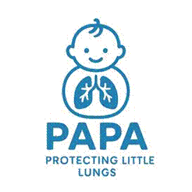
PAPA Stage 1 Parent/Carer Information Sheet for Contact
Trial title: Preventing childhood Asthma using Prophylactic house dust mite Allergen immunotherapy

You are being invited to consider including your child in the PAPA trial. All backgrounds and abilities are welcome to take part!
For more information please see our website: https://papastudy.uk
Before you decide it is important for you to understand why the research is being done and what it will involve for your child. Please take time to read the following information carefully and discuss it with others if you wish.
Part 1 – Why is this trial being done? (pages 2 & 3): This section tells you about the purpose of this trial and what will happen if your child takes part.
Part 2 – Participant Privacy Notice (pages 4,5 & 6): This section explains how we will look after all the information collected about your child and use this information properly.
Part 3 – Contact details (page 7): This page includes contact details for the research team.
Ask us if there is anything that is not clear or if you would like more information. Take time to decide whether or not you would wish your child to take part. Thank you for taking the time to consider your child taking part in our trial. If you are happy for your child to participate you will be asked to sign a consent form.

PART 1 - Why is this trial being done?
What is the purpose of the trial?
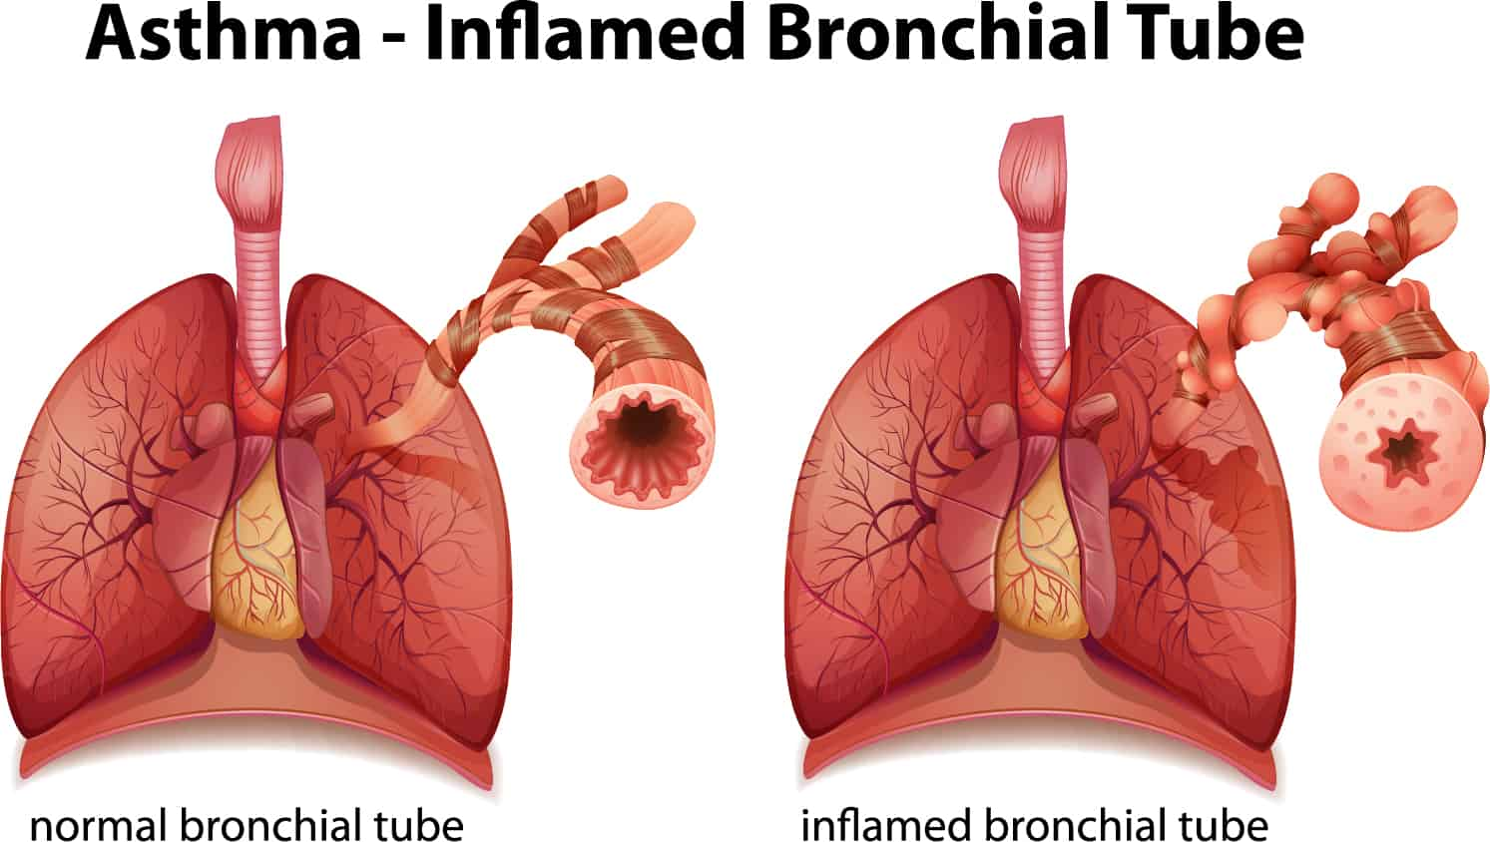
Asthma is a disease which causes wheezing, coughing and/or tightening of the air passages which can be relieved with medication. Asthma is one of the most common long-term illnesses in children and there is no cure, but it may be possible to prevent asthma. Most children in the UK with asthma are allergic to house dust mite (HDM), and this allergy contributes to asthma symptoms.
Asthma – Inflamed Breathing Tube
normal breathing tube
inflamed breathing tube
We already know that if babies are given peanut butter or egg to eat when they are young, they are less likely to develop allergy to peanut or egg. In this trial, we want to test whether using a similar approach with HDM might stop babies developing allergy to HDM and asthma.

Why have I been chosen?
Your child is being asked to participate in this trial as your child is up to 12 months and deemed at high risk of developing persistent (lasting) asthma. A total of 434 patients are being enrolled in this trial at 12 NHS hospitals across the UK.
What will happen to me if I take part in the initial screening?
This is an opportunity to express interest in hearing more about research your child could get involved in called the PAPA trial. If you are happy to be contacted about this research, we will ask you to complete a short online questionnaire and collect your contact details in order to be contacted by a member of the research team for more information.
You are not consenting to taking part in the PAPA trial at this stage, just to be contacted for more information.
Questionnaire: We will collect information on your child’s health and their parents and biological siblings. We will ask questions on their history of allergies and asthma. This will take around 5-10 minutes.
If the answers to your questionnaire indicate your child is suitable for the PAPA trial, a member of the research team will be in touch to discuss the trial further and invite you to a screening visit at the hospital clinic. If you were invited through your child’s GP practice, we will ask for your preferred clinic location before completing the questionnaire.
Do I have to take part?
It is up to you to decide whether or not to take part. If you do decide to take part, you will be given this information sheet to keep and be asked to complete the questionnaire and enter your contact details to be contacted by the site team. If you decide to take part, you are still free to withdraw your child at any time and without giving a reason. A decision to withdraw at any time, or a decision not to take part, will not affect the standard of care your child receives. If you would like to withdraw after agreeing to take part, please speak to your doctor or care team.
Will my child’s details and information be confidential?
Yes. All of you and your child’s personal details will be kept in a pseudonymised format (this means a code number will be used instead of your name and only your care team can link the code with your details) and confidential. We will collect your contact details (name, address, email, telephone number) in order to contact you with further information if your child is suitable.
Who is organising and funding this trial?
The trial is being organised and run by researchers at the University of Southampton and Imperial College London. The main Investigator of the trial is Professor Syed Hasan Arshad. It is funded by the National Institute for Health Research (Efficacy and Mechanism Evaluation programme) and sponsored by University of Southampton. The sponsors of this trial will pay your hospital the costs associated for including your child in this trial.
Who can I contact for independent research information?
If you have any questions about being in a research trial, you can contact the Trust’s Patient Advice Liaison Service (PALS). They will give you advice about who you can talk to for independent advice. The nearest PALS office can be found on the NHS website. You can also ask your GP surgery, hospital or phone NHS111 for details of your nearest PALS.

PART 2 - PARTICIPANT PRIVACY NOTICE
Further information
Thank you in advance for considering participation in this study. If you have any questions about this research, the trial staff will be more than happy to answer them.

How will we use information about you?
We will need to use information from you, your child and your child’s medical records for this research project.
This information will include your child’s initials, partial date of birth (only month and year), NHS/CHI number, your contacts details. People will use this information to do the research or to check your records to make sure that the research is being done properly.
People who do not need to know who you are will not be able to see your child’s name or contact details. Your child’s data will have a code number instead.
The University of Southampton is the sponsor of this research. The sponsor is working with Imperial College London to run this trial.
The University of Southampton is responsible for looking after your information. We will share your information related to this research project with the following types of organisations:
- Sponsor representative, Imperial College London
- Pharmaceutical company, ALK-Abello
- MedSearch (app used to track medication adherence)
We will keep all information about you safe and secure by:
- Aside from Imperial College London and your local NHS site, no one will have access to your personal data. ALK-Abello and MedSearch will only have access to anonymised trial data; this means data will only be identified by a unique code number.
International transfers
We may share or provide access to data about you outside the UK for research related purposes to:
- Ensure safety monitoring
- Analyse research samples
If this happens, we will only share the data that is needed. We will also make sure you can’t be identified from the data that is shared where possible. This may not be possible under certain circumstances – for instance, if you have a rare illness, it may still be possible to identify you. If your data is shared outside the UK, it will be with the following sorts of organisations:
- ALK-Abello, the company who provide the trial medication, based in Demark
We will make sure your data is protected. Anyone who accesses your data outside the UK must do what we tell them so that your data has a similar level of protection as it does under UK law. We will make sure your data is safe outside the UK by doing the following:
- The country (Denmark) your data will be shared with has an adequacy decision in place. This means that we know their laws offer a similar level of protection to data protection laws in the UK
- we use specific contracts approved for use in the UK which give personal data the same level of protection it has in the UK. For further details visit the Information Commissioner’s Office (ICO) website: https://ico.org.uk/for-organisations/uk-gdpr-guidance-and-resources/international-transfers/
- we do not allow those who access your data outside the UK to use it for anything other than what our written contract with them says
- we need other organisations to have appropriate security measures to protect your data which are consistent with the data security and confidentiality obligations we have. This includes having appropriate measures to protect your data against accidental loss and unauthorised access, use, changes or sharing.
How will we use information about you after the study ends?
Once we have finished the study, we will keep some of the data so we can check the results. We will write our reports in a way that no-one can work out that you took part in the study.
We will keep your study data for a maximum of 10 years. The study data will then be fully anonymised and securely archived or destroyed.
What are your choices about how your information is used?
- you can stop being part of the study at any time, without giving a reason, but we will keep information about you that we already have
- if you choose to stop taking part in the study, we would like to continue collecting information about your health from central NHS records including your hospital and your GP. If you do not want this to happen, tell us and we will stop
- you have the right to ask us to access, remove, change or delete data we hold about you for the purposes of the study. You can also object to our processing of your data. We might not always be able to do this if it means we cannot use your data to do the research. If so, we will tell you why we cannot do this
- If you agree to take part in this study, you will have the option to take part in future research using your data saved from this study.
Where can you find out more about how your information is used?
You can find out more about how we use your information, including the specific mechanism used by us when transferring your personal data out of the UK:
- our leaflet - www.hra.nhs.uk/patientdataandresearch
- by asking one of the research team
- by contacting our UK representative at Imperial Clinical Trials Unit – papatrial@imperial.ac.uk
- by contacting the Sponsors Data Protection Officer - data.protection@soton.ac.uk

Thank you for taking the time to consider participating in this trial.
If you accept to participate a copy of this information sheet will be given to you.

PART 3 – Contact Details
Contact for Further Information
If you wish to ask any questions or speak to a member of the research team, please, use any of the following contact details:
Name: [name of doctor and/or nurse]
Telephone number: [phone number]
Email: [email]

If you are unhappy or have a complaint about any aspect of this study, please contact:
University of Southampton Head of Research Ethics and Governance details:
Telephone: 023 8059 5058
Email: rgoinfo@soton.ac.uk

